AI-Assisted IoT Framework for Monitoring and Managing Water Quality and Residual Chlorine Levels
Tushar S. Alande^{1, a} Varsha K. Harpale^{1, b}, Aryan A. Bharaswadkar^{1, c}, Siddhant S. Babanagar^{1, d}
¹Dept. Of Electronics and Telecommunication, Pimpri Chinchwad College of Engineering, Pune, India
ª alandetushar10@gmail.com ^{b}varshaks3@gmail.com ^{c} aryanbharaswadkar@gmail.com ^{d} siddhantbabanagar111@gmail.com

Abstract— Clean and safe drinking water is essential for public health, yet many communities lack access to systems that continuously monitor water quality. Existing methods rely heavily on manual sampling and laboratory analysis, which are time-consuming, costly, and incapable of providing real-time data—leading to delayed responses to contamination and poor chlorine regulation. To address these challenges, we propose an AI-assisted IoT framework that enables real-time monitoring and intelligent management of water quality parameters, including pH, TDS, turbidity, electrical conductivity, and residual chlorine. The system uses sensor data integrated with a machine learning model to predict chlorine concentration and detect anomalies, with results displayed through a mobile application for remote access. This solution offers a low-cost, scalable, and efficient approach to ensure water safety in both urban and rural settings.
- Introduction
Water is a fundamental necessity for human life, and ensuring its quality is vital for safeguarding public health. With increasing industrialization, urbanization, and agricultural runoff, the risk of water contamination has grown significantly, leading to health issues such as waterborne diseases and chemical poisoning. Among the various parameters used to assess water quality, residual chlorine plays a crucial role as it ensures disinfection and prevents microbial growth in distribution systems. However, excessive chlorine can lead to harmful byproducts, while insufficient chlorine may result in microbial contamination—making precise control essential.
Traditional water quality monitoring systems depend on periodic manual sampling and laboratory analysis. These methods, although accurate, are limited by high costs, delayed results, lack of continuous monitoring, and inefficiency in responding to sudden changes in water conditions. Such drawbacks make these approaches unsuitable for real-time water safety assurance, especially in remote or resource-limited settings.
To overcome these limitations, this paper presents an AI-assisted Internet of Things (IoT) based framework for real-time monitoring and intelligent management of water quality parameters, particularly residual chlorine levels. The proposed system leverages various sensors connected to an ESP32 microcontroller, which provides both processing power and built-in Wi-Fi capability. It measures critical indicators such as pH, Total Dissolved Solids (TDS), turbidity, electrical conductivity, and chlorine concentration. A machine learning model is employed to predict residual chlorine levels and detect anomalies, thereby enhancing the accuracy and responsiveness of the system. Data is transmitted through the IoT interface and visualized via a mobile application, enabling remote access and timely decision-making. This framework aims to provide a scalable, cost-effective, and efficient solution for continuous water quality assurance in both urban and rural water distribution networks.
- Literature Review
A new real-time online water quality monitoring system is proposed in [1] using the Internet of Things. It integrates an STM32 microcomputer, sensors, WIFI wireless transmission, and remote water quality management. The system monitors water quality parameters like turbidity, pH, and temperature and uploads data to a management centre via wireless communication. The mentioned system in [2] develops an integrated IoT-based system for environmental water management monitoring, utilizing Raspberry Pi for sensor manufacturing and remote communication technology for data exchange. [3] proposes a wireless sensor network technology-based water quality monitoring system to address issues like poor real-time performance, secondary pollution, and high costs, aiming to prevent environmental pollution and achieve efficient and intelligent water quality. The work proposed in [4] describes a system using an industrial multi-parameter sensor node, EXO Sonde, to extract desired sensor values from the physical world, process and communicate data to a server via a layered architecture, and store and visualize data in a web UI. [5] presents a low-cost internet-of-things system for monitoring and evaluating water quality in rural settlements. It uses an Arduino UNO board, Bluetooth module, temperature sensor, pH sensor, TDS sensor, and turbidity sensor, controlled via mobile application.
Wireless communication advancements are improving sensor capabilities in environmental applications, such as water quality monitoring. [6] explains how IoT technology allows data exchange among devices, enhancing automation and monitoring drinking water quality through a cost-effective system. [7] presents a water quality monitoring system using an Arduino development board and Bluetooth technology. The system collects pH, turbidity, conductivity, and water temperature data, which are sent to a smartphone via Bluetooth. The system accurately obtains water quality parameters and operates stably, making it suitable for various water quality monitoring purposes. A microcontroller prototype with sensors was tested for reliability, but reliant on human assistance and prone to data inaccuracies. [8] provides a foundation for future IoT-friendly expansion. [9] presents a real-time water quality monitoring system using IoT, utilizing a microcontroller and sensors to detect deviations from WHO standards in a water treatment plant. [10] presents a real-time water quality monitoring and control system using IoT, utilizing a microcontroller and sensors to detect deviations from WHO standards, triggering autonomous control measures.
[11] presents the Water Quality Monitoring System for Inland Lakes (WQMSIL), utilizing remote sensing and ground-based observation data to monitor water quality in inland lakes. It details system requirements, framework, structure, and features. The system uses Raspberry Pi, an Analog Digital Converter, and water quality sensors to detect water temperature, dissolved oxygen, pH, and electrical conductivity in real-time. [12] provides stakeholders with graphical and tabular information for quick action. An IoT-based real-time water quality monitoring system in [13] integrated with a mobile application, measures key water indexes like hydrogen potential, TDS, turbidity, and temperature, aiding in environmental conservation and Earth's health improvement. This study presents a low-cost water quality measurement device called the Kolora meter, developed using IoT technology. [14] uses the Arduino UNO model and NodeMCU board for microcontroller and Wi-Fi connection. The device measures temperature and turbidity, which can be viewed and monitored on a mobile phone via the Kolora Mobile Application. This device has the potential for real-time pollution detection during the COVID-19 pandemic. [15] represents a low-cost, real-time water quality monitoring system which can be applied in remote rivers, lakes, coastal areas and other water bodies is presented. To design the proposed water quality monitoring system for this study, the sensors used and the system design are discussed in this section.
[16] proposes a solar PV-based system using Wireless Sensor Networks (WSN) technology for accurate water quality monitoring. The system uses three sensors: pH, turbidity, and temperature sensors, connected to Arduino, GSM, and LCD for communication and monitoring. The system uses a solar panel and lead-acid battery for autonomy, making it suitable for remote areas and applications in agriculture, aquaculture, domestic, and small industrial setups. [17] presents a smart water quality monitoring system for the Fiji Islands, utilizing IoT and remote sensing technology, to improve water quality monitoring, prevent water-borne diseases, and enhance quality of life. Sensors connected to Arduino-uno detect water parameters, displaying them in a desktop application. Continuous monitoring of water quality ensures a safe water supply, improving health and living standards for all living things. This paper presents a sensor-based water quality monitoring system using a Wireless Sensor Network (WSN), microcontroller, communication system, and sensors, enabling real-time data access via remote monitoring and IoT technology [19] .
- Methodology
The proposed system is designed to monitor and manage water quality in real time using an AI-assisted IoT framework. The architecture consists of two sensor nodes positioned at the inlet and outlet of a household or community water tank. Each node is built around an ESP32 microcontroller, which handles sensor interfacing, data processing, and wireless transmission to a cloud platform.
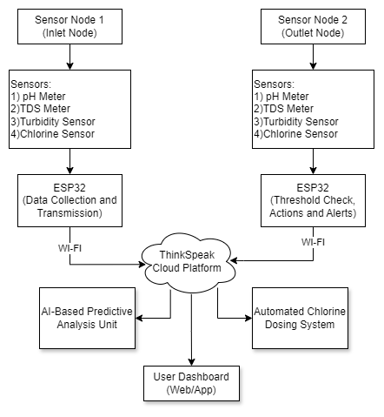
Figure 1
3.1 Sensor Node Architecture:
The inlet node functions primarily as a monitoring unit. It continuously collects raw water quality data to assess the input water condition before storage. Sensors connected to the inlet node include pH Sensor, TDS Sensor, Turbidity Sensor, Electrical Conductivity Sensor, Water Flow Sensor, Water Level Sensor. The purpose of the inlet node is to gather real-time data on the incoming water supply. No alerts or actions are triggered at this stage; data is simply logged and sent to the cloud for analysis. The outlet node plays a more active role by performing both data monitoring and threshold-based checks. It uses the same set of sensors as the inlet node and includes an additional residual chlorine sensor to evaluate the disinfectant level before water is delivered to users. If any parameter exceeds predefined safe thresholds (e.g., high turbidity, low chlorine), the system can trigger alerts or recommend corrective actions. This node is critical for ensuring that water dispensed from the tank is safe for consumption.
3.2 IoT and Wireless Architecture:
The system’s IoT architecture is built around the ESP32 microcontroller, which offers both data acquisition and integrated Wi-Fi capability, eliminating the need for external communication modules. Each sensor node collects multi-parameter data and transmits it wirelessly to the ThingSpeak cloud platform using MQTT or HTTP protocols. ThingSpeak provides real-time data visualization, storage, and easy API access for AI model integration. The use of a wireless architecture enables flexible deployment of sensor nodes in locations without existing communication infrastructure, making the system highly suitable for both urban and remote environments. Additionally, the nodes operate in a low-power mode between transmissions to ensure energy efficiency. The decentralized sensing architecture combined with centralized cloud analysis ensures real-time feedback, historical trend analysis, and remote accessibility through web or mobile interfaces.
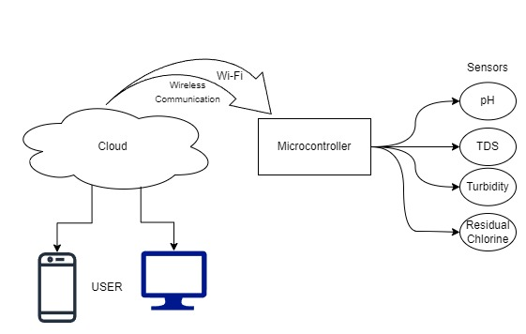
Figure 2
3.3 Cloud Integration and Data Handling
Both sensor nodes send data to the ThingSpeak IoT platform via Wi-Fi. ThingSpeak acts as the central data repository and visualization platform, enabling real-time monitoring and historical data analysis. The collected sensor data is used in two AI-driven modules:
- Water Tank Cleaning Schedule Prediction: Using historical water quality trends and machine learning algorithms, the system predicts the optimal cleaning schedule for the water tank. This prevents unnecessary cleanings while avoiding water contamination due to delayed maintenance.
- Water Quality Index (WQI) Prediction: An AI model is trained to calculate a composite Water Quality Index based on sensor data. The WQI helps users and authorities understand overall water quality at a glance, using a scale that reflects safe, cautionary, or hazardous conditions.
3.3 Automated Alerts and User Notifications
The system incorporates an automated alert mechanism to ensure timely response to any detected anomalies in water quality. The outlet sensor node continuously compares real-time sensor readings against predefined safety thresholds. If parameters such as pH, turbidity, TDS, or residual chlorine exceed or fall below safe limits, the system immediately triggers an alert. These alerts are sent to users via email notifications or mobile push messages, ensuring that corrective actions can be taken promptly—such as cleaning the tank, checking filters, or stopping distribution. This automated notification system enhances user awareness and provides a proactive approach to maintaining water safety without requiring constant manual monitoring.

- Experimental Analysis And Results
The system was tested on 10 water samples collected from various rivers and dams in the vicinity. The actual values were measured using standard equipment, and the results were compared with the sensor readings from the Smart Water Quality Monitoring System and plotted in Figure 6 and 7.
The pH sensor showed good performance, providing measurements that were generally close to the actual pH values. The TDS sensor demonstrated excellent accuracy, with its readings closely matching the actual TDS values across multiple samples. Both sensors performed consistently, with only minor deviations from the actual values, which were within acceptable limits. These results indicate that the sensors are effective for monitoring water quality and can be relied upon for accurate data collection and analysis in the system.
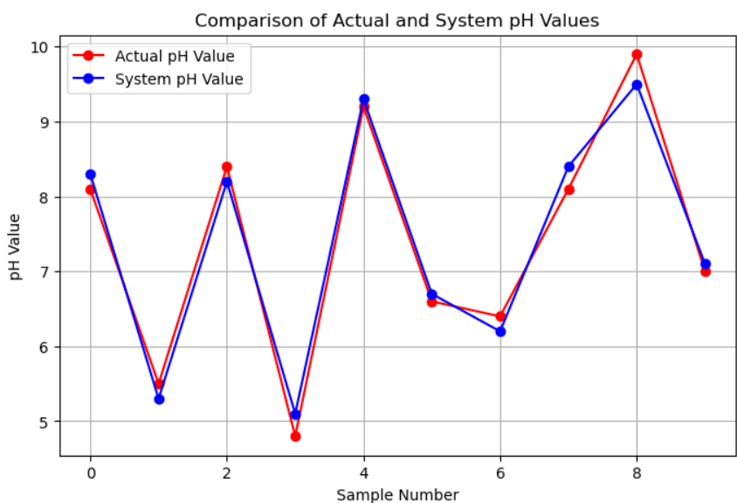
Figure 8- Comparison of pH Values
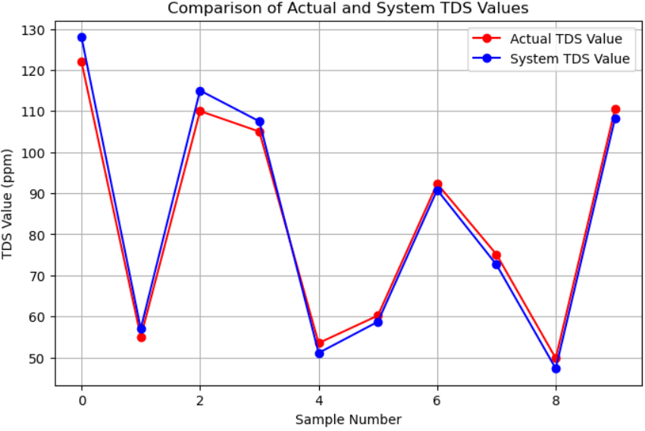
Figure 9- Comparison of TDS Values
Following the comparison of actual values with sensor readings, the Smart Water Quality Monitoring System displayed the real-time results on the integrated 16x2 LCD screen. The LCD shown in figure 8 and 9 provide clear and immediate feedback on the pH and TDS values for each water sample, allowing for easy monitoring of water quality parameters on-site. Below are the photos of the readings as they appeared on the LCD during testing, showcasing the system's functionality and accuracy in displaying vital water quality data.
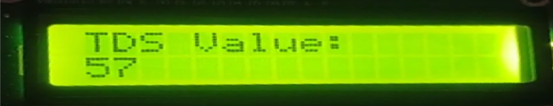
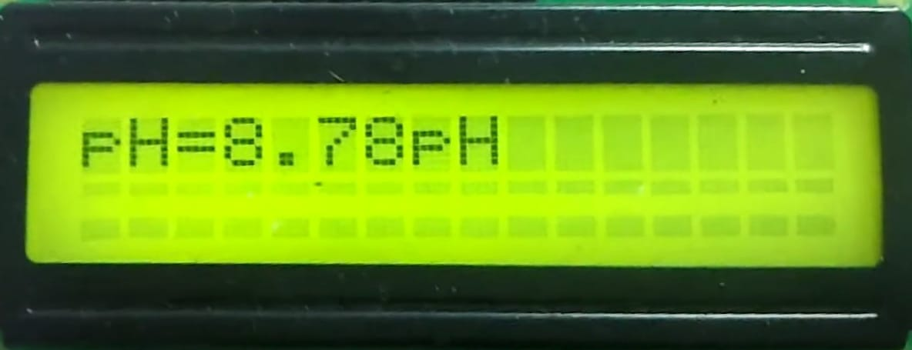
Figure 10- LCD Screen
These images demonstrate the effectiveness of the system in providing real-time information, which is crucial for quick decision-making and ensuring water safety.
- Conclusion
The Smart Water Quality Monitoring System developed in this study effectively addresses the need for real-time, on-site monitoring of water quality parameters. By integrating a microcontroller with multiple sensors. the system provides accurate and reliable measurements of key indicators such as pH levels, total dissolved solids (TDS), water levels, and flow rates. Through systematic testing on ten water samples from various rivers and dams, the sensors demonstrated consistent performance, with results closely aligning with those obtained using standard laboratory equipment.
The Smart Water Quality Monitoring System offers an accessible and cost-effective solution for continuous water monitoring, significantly enhancing water quality management and public health safety. Its successful implementation demonstrates its value, particularly in areas where traditional testing methods are impractical. The system's adaptable design also makes it a versatile tool in the ongoing effort to protect and manage clean water resources.
References
- C. Zhang, J. Wu and J. Liu, "Water quality monitoring system based on Internet of Things," 2020 3rd International Conference on Electron Device and Mechanical Engineering (ICEDME), Suzhou, China, 2020, pp. 727-730, doi: 10.1109/ICEDME50972.2020.00171.
- R. P. N. Budiarti, A. Tjahjono, M. Hariadi and M. H. Purnomo, "Development of IoT for Automated Water Quality Monitoring System," 2019 International Conference on Computer Science, Information Technology, and Electrical Engineering (ICOMITEE), Jember, Indonesia, 2019, pp. 211-216, doi: 10.1109/ICOMITEE.2019.8920900.
- Q. BAI, J. Wu and C. JIN, "The Water Quality Online Monitoring System Based on Wireless Sensor Network," 2020 13th International Symposium on Computational Intelligence and Design (ISCID), Hangzhou, China, 2020, pp. 234-237, doi: 10.1109/ISCID51228.2020.00059.
- K. S., S. T.V., M. S. Kumaraswamy and V. Nair, "IoT based Water Parameter Monitoring System," 2020 5th International Conference on Communication and Electronics Systems (ICCES), Coimbatore, India, 2020, pp. 1299-1303, doi: 10.1109/ICCES48766.2020.9138001.
- Bogdan, R.; Paliuc, C.; Crisan-Vida, M.; Nimara, S.; Barmayoun, D. Low-Cost Internet-of-Things Water-Quality Monitoring System for Rural Areas. Sensors 2023, 23, 3919. https://doi.org/10.3390/s23083919
- Pasika S, Gandla ST. Smart water quality monitoring system with cost-effective using IoT. Heliyon. 2020 Jul 1;6(7):e04096. doi: 10.1016/j.heliyon.2020.e04096. PMID: 32642574; PMCID: PMC7334377.
- C. Feng, J. Yuan, Y. Sun and J. You, "Design of Water Quality Monitoring System," 2020 International Conference on Artificial Intelligence and Computer Engineering (ICAICE), Beijing, China, 2020, pp. 264-267, doi: 10.1109/ICAICE51518.2020.00057.
- Hong, Wong Jun, Norazanita Shamsuddin, Emeroylariffion Abas, Rosyzie Anna Apong, Zarifi Masri, Hazwani Suhaimi, Stefan Herwig Gödeke, and Muhammad Nafi Aqmal Noh. 2021. "Water Quality Monitoring with Arduino Based Sensors" Environments 8, no. 1: 6. https://doi.org/10.3390/environments8010006
- Hong WJ, Shamsuddin N, Abas E, Apong RA, Masri Z, Suhaimi H, Gödeke SH, Noh MNA. Water Quality Monitoring with Arduino-Based Sensors. Environments. 2021; 8(1):6. https://doi.org/ 10.3390/ environments8 010006
- Allen T. Chafa, Gibson P. Chirinda & Stephen Matope (2022) Design of a real-time water quality monitoring and control system using Internet of Things (IoT), Cogent Engineering, 9:1, 2143054, DOI: 10.1080/23311916.2022.2143054
- Zhou, Zheng, and Yuanling Zhao. "Research on the water quality monitoring system for inland lakes based on remote sensing." Procedia Environmental Sciences 10 (2011): 1707-1711.
- Z. Czyczula Rudjord, M. Reid, C. Schwermer, and Y. Lin, “Ai System for Real-Time Monitoring of Water Quality,” SSRN Electronic Journal, 2022, Published, doi: 10.2139/ssrn.4103356.
- “Retracted: IoT-Based Water Quality Assessment System for Industrial Waste WaterHealthcare Perspective,” Journal of Healthcare Engineering, vol. 2023, pp. 1–1, Jul. 2023, doi: 10.1155/2023/9754956
- I. M. Hakimi and Z. Jamil, “Development of Water Quality Monitoring Device Using Arduino UNO,” IOP Conference Series: Materials Science and Engineering, vol. 1144, no. 1, p. 012064, May 2021, doi: 10.1088/1757-899x/1144/1/012064.
- Demetillo, A.T., Japitana, M.V. & Taboada, E.B. A system for monitoring water quality in a large aquatic area using wireless sensor network technology. Sustain Environ Res 29, 12 (2019). https://doi.org/10.1186/s42834-019-0009-4
- Tahir, Muhammad Usman; Ahsan, Syed Muhammad; Arif, Syed Muhammad; Abdullah, Muhammad (2018). [IEEE 2018 Australasian Universities Power Engineering Conference (AUPEC) - Auckland, New Zealand (2018.11.27-2018.11.30)] 2018 Australasian Universities Power Engineering Conference (AUPEC) - GSM Based Advanced Water Quality Monitoring System Powered by Solar Photovoltaic System. , (), 1–5. doi:10.1109/AUPEC.2018.8757904
- A.N.Prasad, & Mamun, Kabir & Islam, F. & Haqva, H.. (2015). Smart Water Quality Monitoring System. 10.1109/APWCCSE.2015.7476234.
- Keshipeddi, Sai Bhatt, IoT Based Smart Water Quality Monitoring System (August 13, 2021). Available at SSRN: https://ssrn.com/abstract=3904842 or http://dx.doi.org/10.2139/ssrn.3904842
- IoT Based Real-time River Water Quality Monitoring System, Procedia Computer Science, Volume 155,2019, Pages 161-168, ISSN 1877-0509,https://doi.org/10.1016/j.procs.2019.08.025.

